# Kroning-Penney model for superlattice structure

## 1 band model

### Analytical format for 2 materials, 1 band model

In a superlattice structure, every period consists of a well material with a width of w and barrier material with a width of b. The length of a period is L=w+b. The potential within a period 0 *< z < L* is:

, n is a integer. The bottom of the well is set as 0 potential.

With continous and periodic boundary condition, the allowed energies should satisfy the following equations:

,

### Transfer matrix for 2 materials, 1 band model

To facilitate the input of band alignment parameters, the potentials are redefined as:



With continous and periodic boundary condition, the eigen function is

,

To get a physically meaningful solution, it’s required that 

where 



# The k·p theory for 2 band model

In Bloch Theorem, wave function is given by 

Apply to Schrodinger equation: 

If only two strongly interacting non-degenerate bands are considered (e.g., conduction band and light hole valence band), we call them class A as in Lowdin’s method.

Assuming, we have



A general solution is



,

k has positive imaginary part for electron wave in energy gap and negative part for hole wave in energy gap

 , could be experimentally determined by 

### Basic expression, 2 materials

Assume A,B is the amplitude of wavefunction in wells, C,D is the amplitude of wavefunction in the barrier.

From left to right, the wavefunction is



### Continuity at interface x=0 and b



### Periodic Boundary condition











This formula is very similar to one band model. The only difference is the definition of k and 

### Normalization



## 3 or more materials in 1 period











# Arbitrary layers, one band model

The format of T is similar, only substitute the following terms:



References:

1 Rui Q. Yang and J. M. Xu, "Analysis of transmission in polytype interband tunneling heterostructures", J. Appl. Phys., 72, 4714 (1992).

2 Chang-Zhi Guo, lecutre notes on quantum theory (2008), 8th class, chapter 3.4

3 Shun Lien Chuang, “Physics of photonic devices” (2009), p152

# A simply example

In [J. Appl. Phys. 105, 013115 (2009)], the authors claims that their one band model agrees with the experimental results, the interface coupling of different kinds of holes can be incorporated into the material parameters (e.g. effective mass). However, this over-simplification is very suspicious. I compare it with my 2 band model using standard parameters.

GaSb(24A)/InAs(23.5A) SL

|  |  |  |  |
| --- | --- | --- | --- |
|  | JAP(2009) | SSP(1992) |  |
| mc(InAs) | 0.042 |  |  |
| mh(InAs) | 0.41 | 0.33 |  |
| mc(GaSb) | 0.049 |  |  |
| mh(GaSb) | 0.50 | 0.25 |  |
| dEc | 0.9 | 0.915 |  |
| dEv | 0.5 | 0.53 |  |
| overlap | 0.15 |  |  |

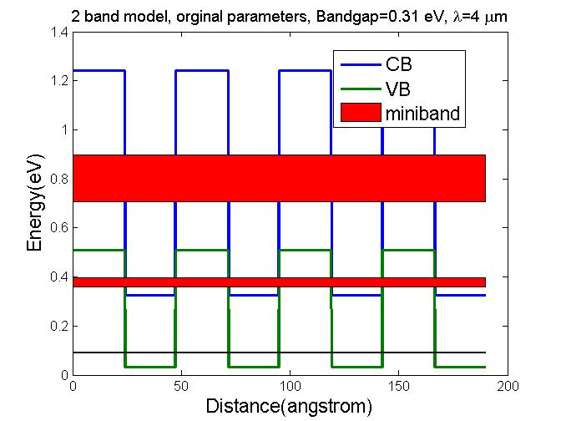 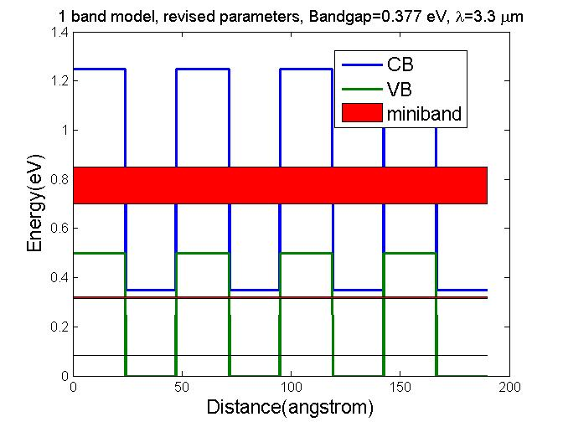

Verdict: This paper is not reliable.